**AASFA SALEEM**

**CodSoft Internship**

**Task 1:**

Mobile App Signup Flow

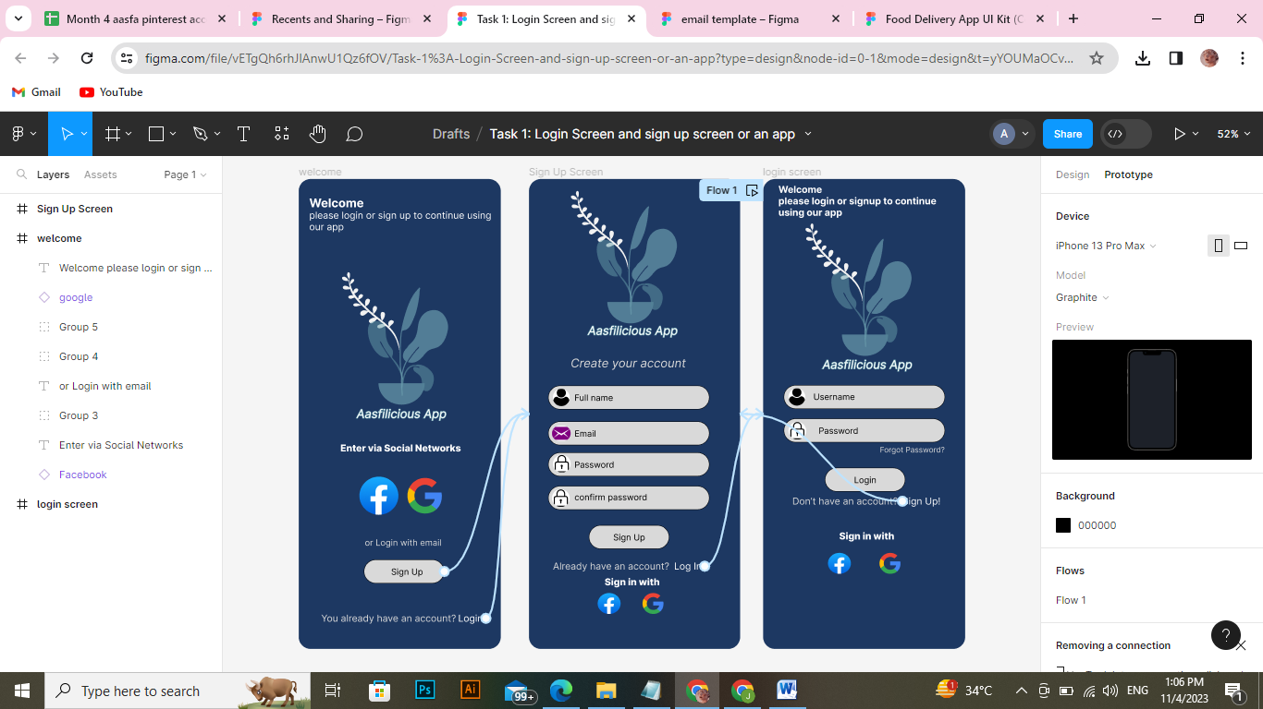

**Task 2:**

Email Template

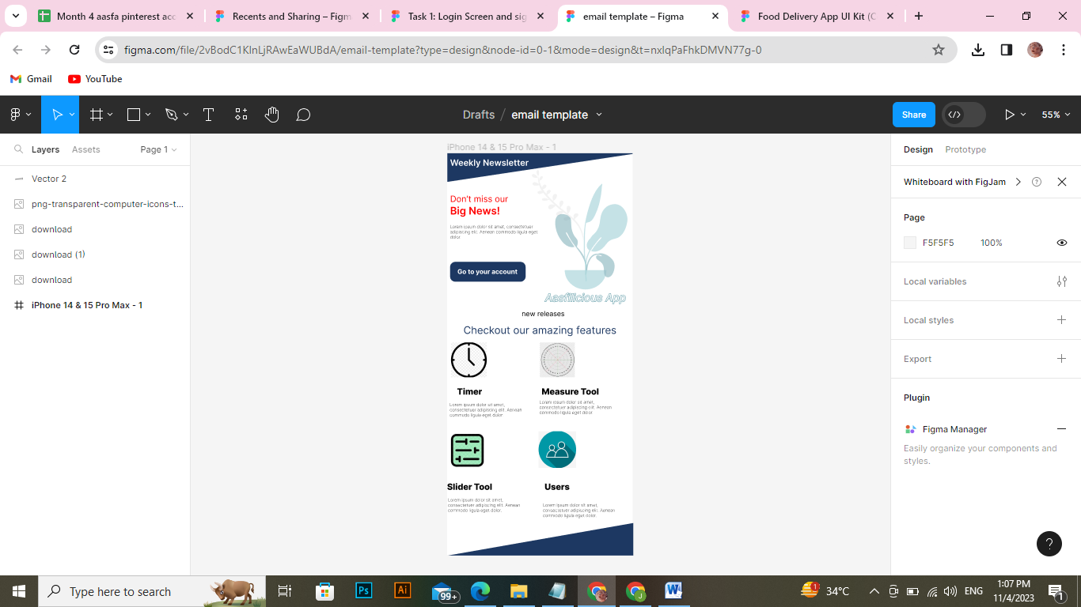

**Task 3:**

Restaurant menu

